|  |
| --- |
| Concordia university |
| Comp6231 |
| PM1-RMI |
| **Team 3** |
| **Gay Hazan**  **Patrick Cristofaro**  **Ross Smith**  **Sai Sun** |
| **2015/6/5** |

# Stock broker based on java rmi

This documentation is intended to provide a systematic view of the stock broker project which features component communications based on java RMI technology.

## Class Hierarchy

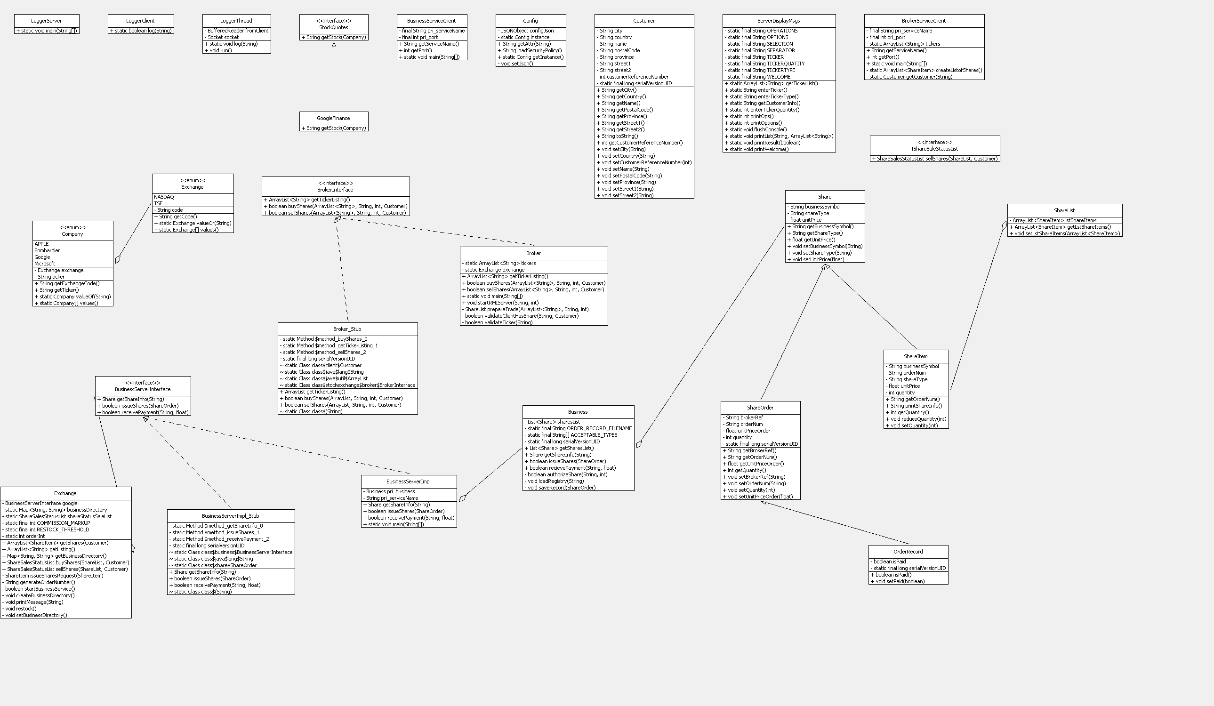

There are two RMI interfaces used in the project, BusinessInterface which is used for internal communication between Exchange service to Business components which in this case stands for business services. Three Business remote objects will be created in remote object registry, and accessible functions are defined in BusinessInterface.

BrokerInterface is used by Exchange service to communicate with client side. It offers operations accessible by clients.

### Class details

* Buiness.java

The concrete logic class for share processing and transaction management. Upon initialization, the correspondent data file will be read and loaded into memory. Once there is a incoming transaction, it will process the transaction and write xml record file to file system. It also create and list the remote objects to RMI registry upon execution.

* BusinessInterface

Java RMI interface definition, internal use for stock broker project.

* OrderRecord

Class used to represent stock order record, used by Business logic to write stock order to record XML file.

* BrokerServiceClient

Front end interface of stock broker project, provides a command line fashion UI.

* Customer

Helper class to represent customer info.

* LoggerServer

Start logger thread on a given port. And communicate with LoggerClient via UDP messages.

* LoggerThread

Contains implementation to write a message to log file.

* Share

Used by Business class to represent share info.

* Broker.java

Implementation of the Broker RMI interface, and also a wrapper for the Exchange class, it redirect user operations to proper function logics inside Exchange class.

* Exchange.java

Concrete class contains logics for exchange processing, has access to three business components, and redirect share processing to proper business component.

## File hierarchy

Stock information are kept in csv files inside files package, for example the contents of the csv files looks like the following sample:

GOOG,COMMON,540.11  
GOOG.B,CONVERTIBLE,532.23  
GOOG.C,PREFERRED,541.28

Log files are created under the same package as well.

Resource directory contains project related resources, e.g. project dependent library jar files, documentations, logs, settings for running the project.

## workflow diagram

